Table of Contents
Introduction 3
Problem Statement 4
Project Objectives 4
Features of the Application 4
Onboarding / Welcome Page 5
User Authentication Interface 5
To-Do List Home Page (Dashboard) 5
Add Task Page 5
UI Design Features 5
System Design 6
Application Architecture 6
Data Structure 6
Navigation Flow 6
User Interface Design 7
Development Tools 7
Testing 8
Results 8
Conclusion 9
Future Improvements 10
References 11
Appendix A: Application Screenshots 12

TECH336: MOBILE APPLICATION DEVELOPMENT
Design and Development of a Basic To-Do Application
Project Title: TaskFlow Smart To-Do List Mobile Application

Introduction
TaskFlow is a mobile productivity application designed to help students and busy individuals manage their daily tasks in a simple, organised, and visually engaging way. The application allows users to create, view, update, and delete tasks through a clean and intuitive interface, removing the friction that often prevents people from sticking to a task management routine.
This project was developed as part of the TECH336 Mobile Application Development module, and its primary purpose is to demonstrate practical mobile application development skills using FlutterFlow, a low-code visual development platform. The assignment required the design and prototyping of a basic To-Do application comprising three to four core pages, with an emphasis on user interface design, page navigation, and basic state management.
Throughout the development process, particular attention was paid to usability and visual consistency. TaskFlow follows a modern Material Design 3 approach, combining rounded components, purposeful colour, and clear typography to deliver an experience that feels professional rather than experimental. The remainder of this document outlines the problem the application addresses, the objectives guiding its design, its features, the underlying system architecture, the tools used in its construction, and the outcomes of testing and evaluation.

Problem Statement
Many students and young professionals struggle to organise their daily activities, which often results in poor time management, missed deadlines, and reduced overall productivity. While numerous task management applications already exist on the market, a large proportion of them are either overly complex for casual use, cluttered with features that most users never touch, or simply unappealing from a visual standpoint.
This creates a gap for a lightweight, visually engaging alternative that focuses on the essentials: adding a task, viewing it clearly, and marking it as complete, without unnecessary friction. TaskFlow was conceived to address this gap directly.
TaskFlow addresses this problem by providing:
- A simple, distraction-free interface
- Easy and immediate task tracking
- Clean, predictable navigation between screens
- Visual organisation of tasks by status and priority

Project Objectives
The development of TaskFlow was guided by the following objectives:
- To design a user-friendly mobile application interface suitable for everyday task management.
- To allow users to create, view, and manage a personal list of daily tasks.
- To implement clear and consistent navigation between multiple application screens.
- To demonstrate sound UI/UX design principles, including consistency, simplicity, and visual hierarchy.
- To build a responsive mobile application prototype using FlutterFlow, in line with the requirements of the TECH336 assignment brief.

Features of the Application
TaskFlow was built around the required pages specified in the assignment brief: an Onboarding/Welcome page, a Login/Sign-up page, a To-Do List Home page (Dashboard), and an Add Task page. Each page was designed to fulfil a specific role in the overall user journey, from first impression through to daily task management.

Onboarding / Welcome Page
The onboarding page is the very first screen a new user encounters. It introduces the application by name, gives a brief description of its purpose, and presents a prominent “Get Started” button that navigates the user directly to the login page. Its purpose is purely orientational: to introduce the task management functionality to new users before they commit to creating an account.

User Authentication Interface
The authentication screen provides a login page with email and password input fields, together with basic client-side validation UI to indicate incomplete or incorrectly formatted entries. Although no backend authentication service was connected for this prototype, the interface was designed to reflect a realistic sign-in experience, including field labels, placeholder text, and a clearly styled submit button.

To Do List Home Page (Dashboard)
The dashboard is the central hub of the application. It displays a personalised greeting message, summary statistics for total, completed, and pending tasks, and a scrollable list of all tasks presented as cards. Each task card includes a checkbox or icon that allows the user to mark the task as completed, and a floating action button provides quick access to the Add Task page.

Add Task Page
The Add Task page allows users to create a new task by entering a title in a required input field and, optionally, a longer description. A Save/Add button commits the new task, after which the user is returned automatically to the dashboard, where the newly created task appears at the top of the list. This closed-loop flow keeps task creation quick and frictionless.

UI Design Features
Across all screens, TaskFlow applies a consistent set of visual design choices: Material Design 3 components, rounded cards and buttons, clean sans-serif typography, subtle gradient accents and drop shadows, and a fully mobile-responsive layout that adapts gracefully to different screen sizes.

System Design

Application Architecture
TaskFlow follows a simple, UI-based architecture built entirely within FlutterFlow, organised into three logical layers:
- UI Layer — the individual screens (Onboarding, Login, Dashboard, Add Task).
- Component Layer — reusable widgets such as task cards, buttons, and input fields.
- Navigation Layer — the page-routing logic that connects the screens together.
No complex backend integration was required for this prototype; mock/local data was used to demonstrate functionality, in line with the scope defined in the assignment brief.

Data Structure
Each task record within the application is modelled with the following fields:
- Task ID — a unique identifier for the task
- Title — the short name of the task
- Description — optional additional detail
- Due Date — the date by which the task should be completed
- Priority — Low, Medium, or High
- Status — Pending or Completed
- Created Date — the date the task was added

Navigation Flow
The navigation structure follows a linear, predictable path designed to minimise user confusion:
- Splash Screen → Login Screen → Dashboard → Add Task Screen → Dashboard
Two optional screens a Completed Tasks screen and a Profile screen were considered as extensions to this core flow and are discussed further in Section 11.0, Future Improvements.

User Interface Design
The interface of TaskFlow was designed to be modern, minimal, and user-friendly, guided by five core design principles: consistency, simplicity, visual hierarchy, spacing based on an 8-point grid system, and accessibility. Together, these principles ensure that the application feels coherent from screen to screen while remaining easy to scan and operate with one hand.
The colour palette and typography below were applied consistently across every screen to reinforce brand identity and readability:
Design Element | Value
Primary Blue | #2563EB
Background | #F8FAFC
Success Green | #10B981
Warning Orange | #F59E0B
Error Red | #EF4444
Typography | Poppins / Inter font family

Development Tools
The following tools were used in the design and development of TaskFlow:
- FlutterFlow — the primary low-code platform used to build and prototype the application
- Figma — used for initial UI design and prototyping before implementation
- AI-assisted design tools — used to accelerate UI generation and refine visual design decisions
- Icons8 and Material Icons — used for icons and supporting UI elements throughout the application

Testing
The application was tested manually across the four required pages to confirm that navigation, task creation, and general responsiveness behaved as expected prior to submission. The table below summarises the test cases performed and their outcomes.
Test Case | Result
Navigation between all screens functions correctly | Pass
New tasks can be added successfully from the Add Task page | Pass
UI elements resize and respond correctly across screen sizes | Pass
Buttons and form fields function as expected | Pass

No major bugs were identified during this round of testing. Minor visual adjustments — such as spacing and alignment on smaller screen sizes — were made iteratively during development.

Results
The final prototype successfully demonstrates the core requirements set out in the assignment brief. Specifically, TaskFlow delivers:
- A fully functional to-do list interface covering onboarding, authentication, dashboard, and task creation
- A clean, modern, and visually consistent UI design
- A logical and predictable navigation flow between all required pages
- Core task management functionality, including adding tasks and marking them as completed
- A responsive layout suitable for a range of mobile screen sizes
Overall, the completed application meets the functional and design requirements defined in the TECH336 Assignment 1 brief.

Conclusion
TaskFlow is a simple yet effective productivity application that demonstrates core principles of mobile UI/UX design and low-code application development using FlutterFlow. Through this project, practical experience was gained in structuring multi-screen navigation, designing reusable UI components, and applying a consistent visual identity across an entire application.
The project successfully achieved its stated objective: the creation of a user-friendly task management prototype with a modern interface, smooth navigation, and functional task tracking, all built within the scope and constraints of a low-code development environment.

Future Improvements
While the current prototype satisfies the requirements of this assignment, several enhancements have been identified that would extend TaskFlow into a more complete, production-ready product:
- Cloud database integration (e.g. Firebase) to persist tasks beyond a single session
- Full user account creation and authentication
- Push notifications for upcoming or overdue task reminders
- A dark mode theme option
- Task sharing and collaboration between multiple users
- Calendar integration for due-date visualisation and scheduling

References
FlutterFlow (2026) FlutterFlow Documentation. Available at: https://flutterflow.io (Accessed: 4 July 2026).
Google (2026) Material Design 3 Guidelines. Available at: https://m3.material.io (Accessed: 4 July 2026).
Google (2026) Flutter Documentation. Available at: https://flutter.dev (Accessed: 4 July 2026).
Icons8 (2026) Icons8 Icon Library. Available at: https://icons8.com (Accessed: 4 July 2026).

Appendix A: Application Screenshots
- Onboarding / Welcome page
- 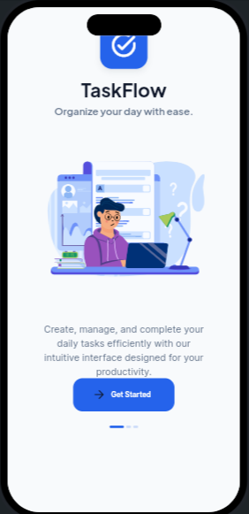
- Login / Sign-up page
- 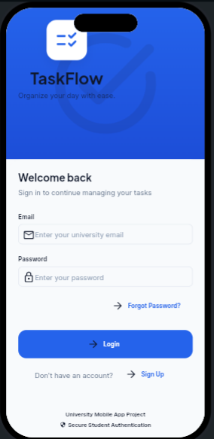
- To-Do List page (Dashboard)
- 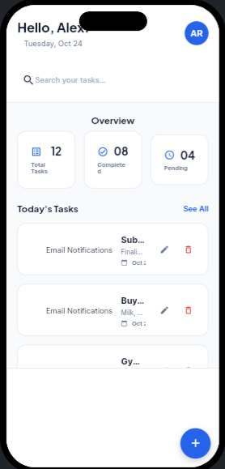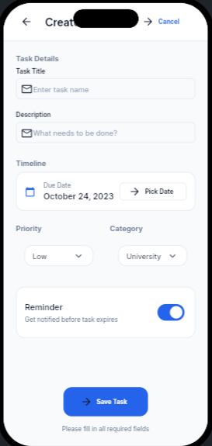
- Add Task page
- 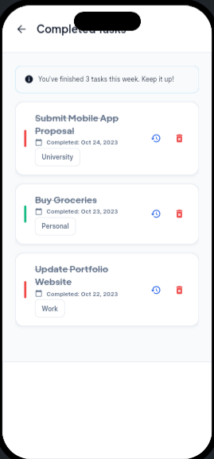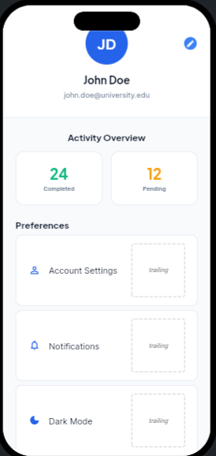
FlutterFlow : https://app.flutterflow.io/project/task-flow-mhzxwt

